Recruited Students - MBA (2022-24)
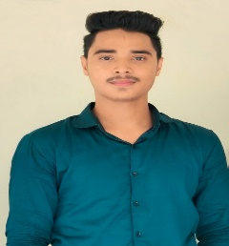
Lakshay
Placed in: VVDN Technology (Rewari)
Package: 4 lakhs
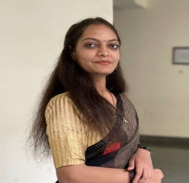
Avantika Mishra
Placed in: Maruti Suzuki
Package: 3.6 lakhs
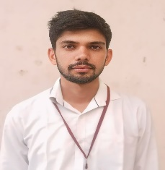
Sachin
Placed in: Axis Bank (Neemrana)
Package: 3.25 lakhs

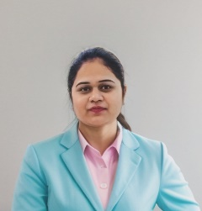
Komal Chawla
Manish Chandra & Associates (Bawal)
Package: 3.6 lakhs
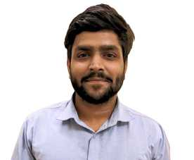
Gunesh Swami
Mount Shivalik Industries Ltd. (Behror)
Package: 3 lakhs
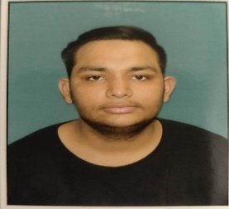
Aditya Kabra
Placed in: RR Kabel (Jaipur)
Package: 4.5 lakhs

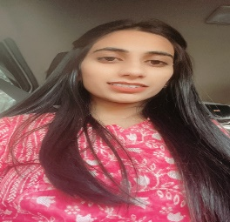
Jyoti Rathore
Quality Council of India (Gurugram)
Package: 4 lakhs

Monu
Raffles University (Neemrana)
Package:2.4 Lakhs
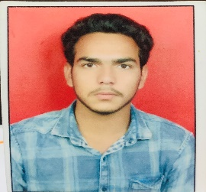
Himanshu
Nerolac Paints (Bawal)
Package: 3 Lakhs

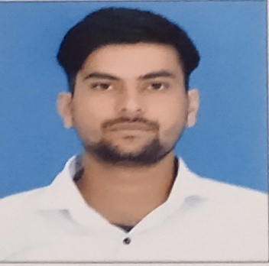
Vinay Kumar
IOP Paints (Neemrana)
Package: 3.6 lakhs
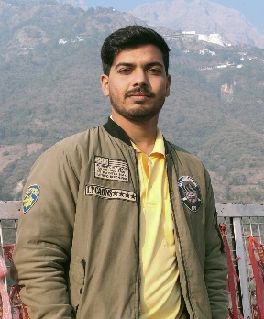
Amit
IOP Paints (Neemrana)
Package: 4 lakhs
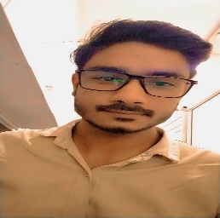
Lalit
Bhagya Decor (Rewari)
Package: 3.5 Lakhs

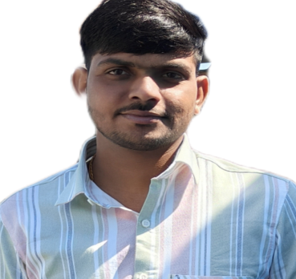
Anil Kumar
IOP Paints (Neemrana)
Package:4 lakhs

Bhumi Bhardwaj
Raffles University
(Neemrana)
Package: 2.4 lakhs
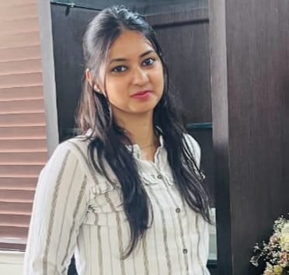
Saniya Joshi
Raffles University (Neemrana)
Package: 2.4 lakhs

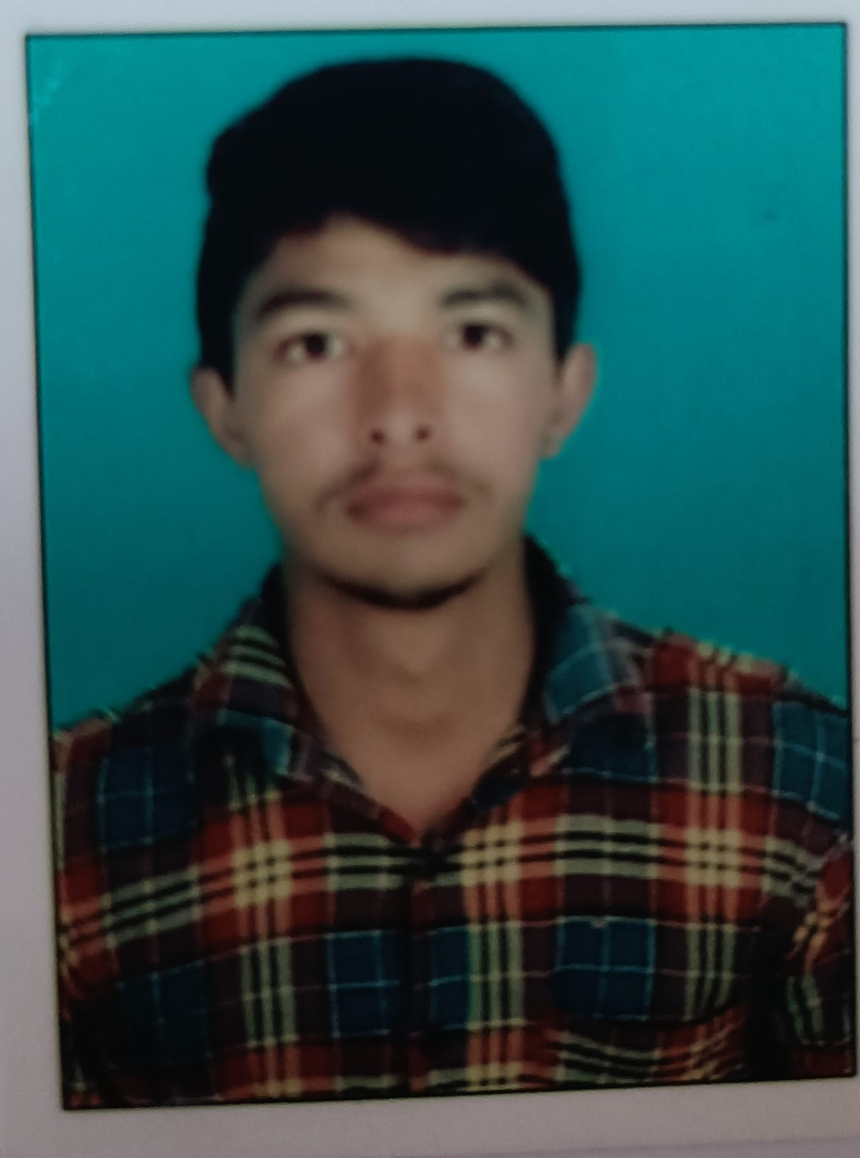
Bhupender
OJI Packaging (Neemrana)
Package: 3 lakhs
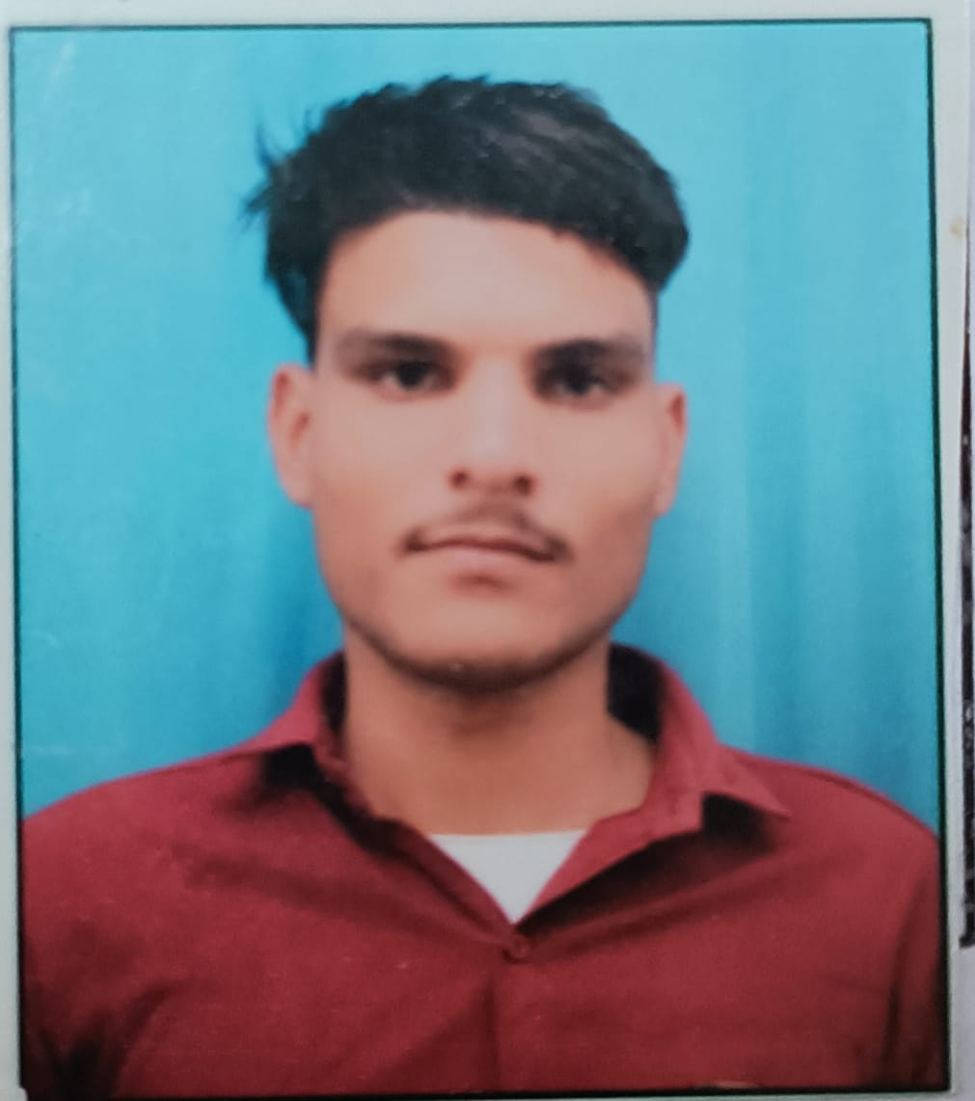
Bhupender
Days Hotel (Shahjahanpur)
Package: 3.6 lakhs

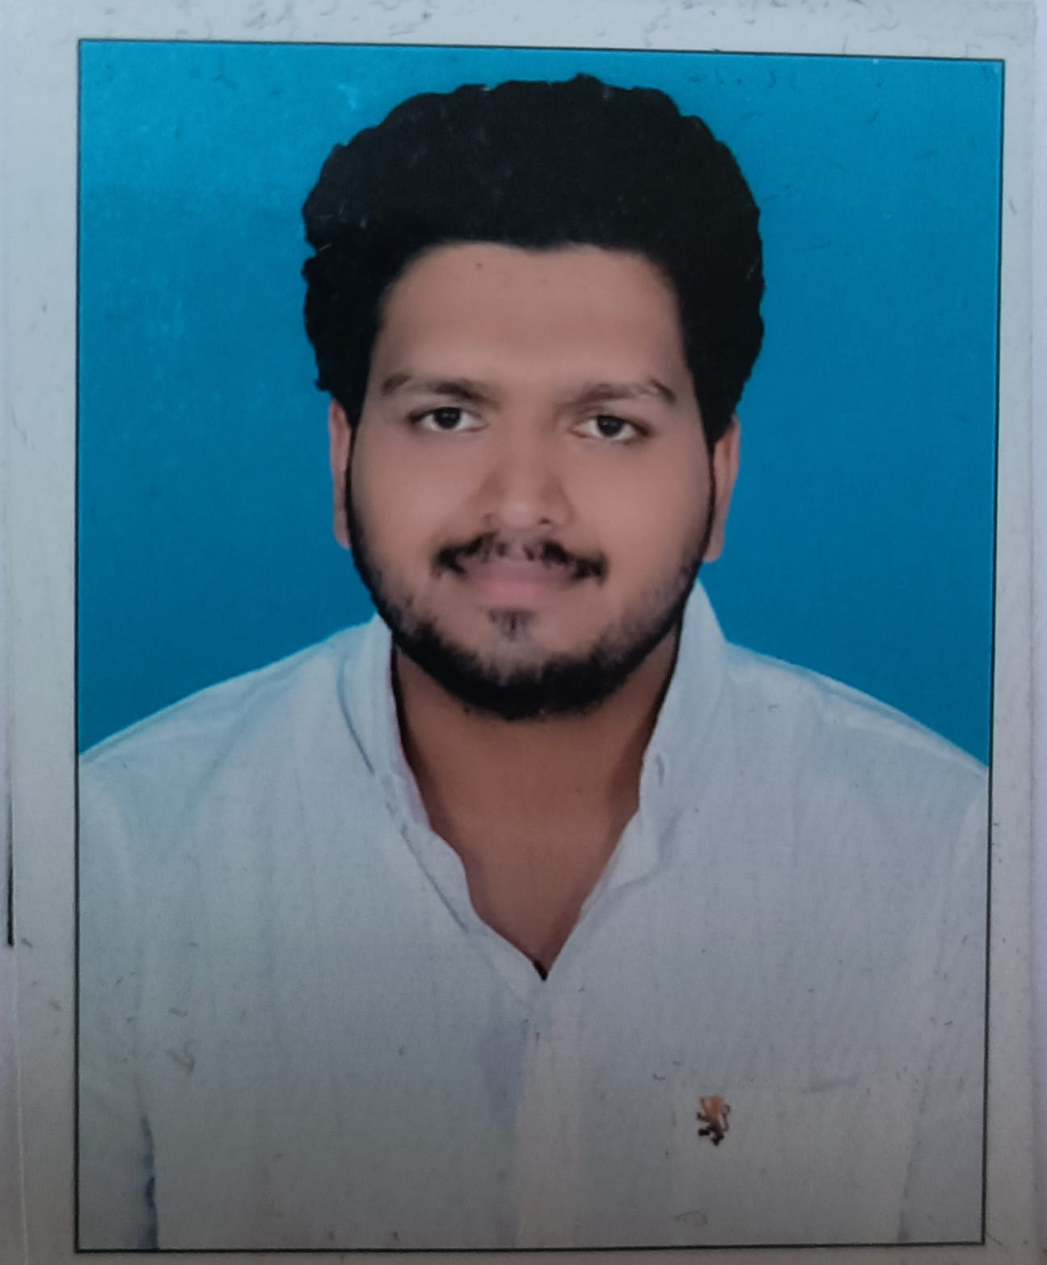
Aman
Bajaj Finance (Bawal)
Package: 3 lakhs

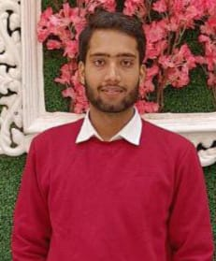
Vansh
Y & A Associates (Bawal)
Package: 4.5 lakhs
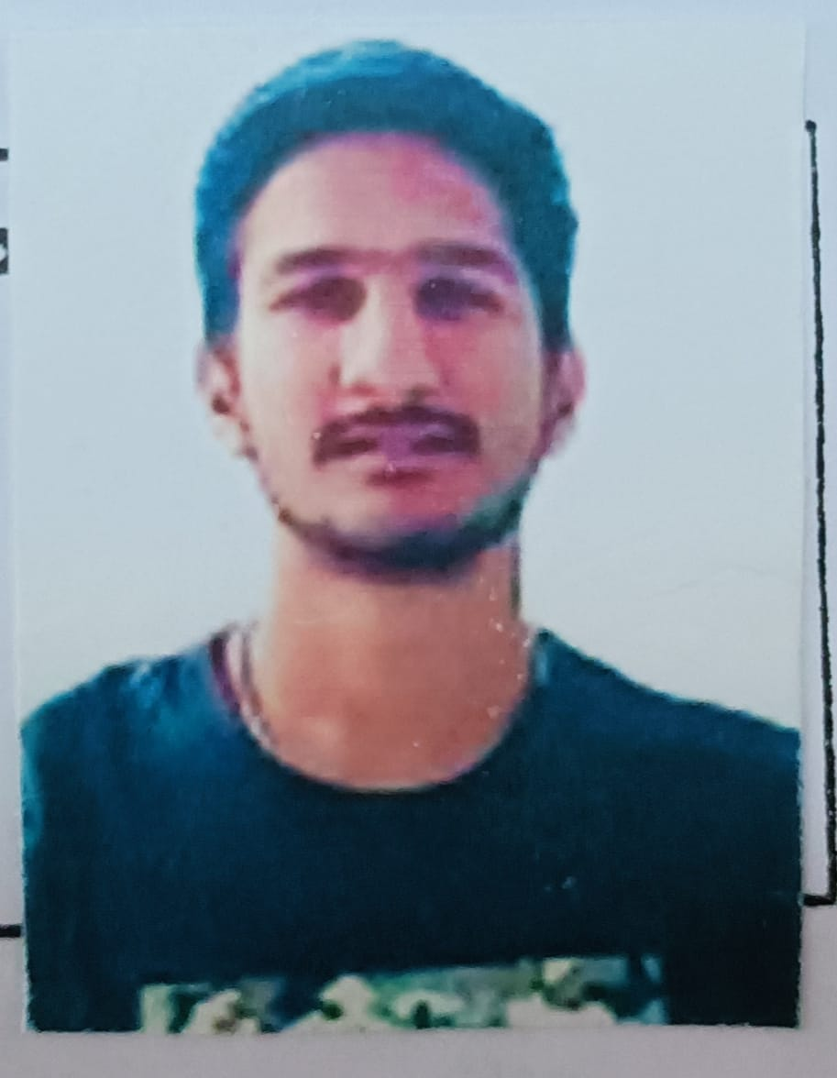
Pukhraj Bhadana
Greenlam Laminates (Behror)
Package: 4 lakhs

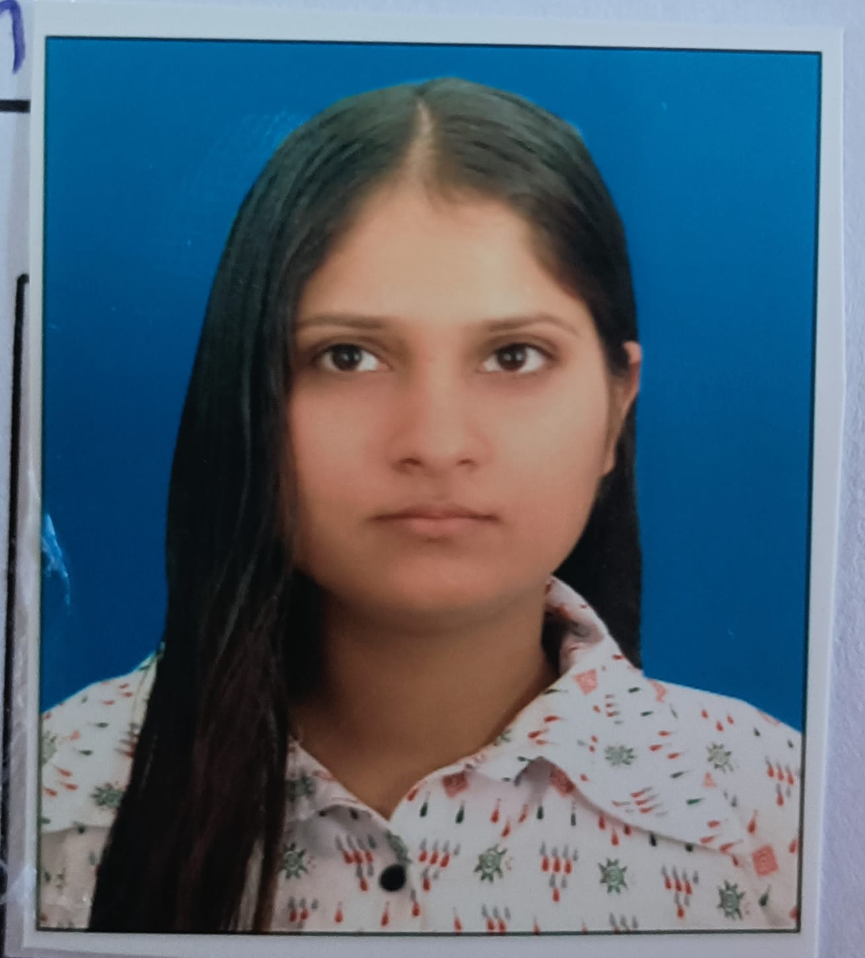
Chanchal
Omniplast (Bawal)
Package: 2.4 lakhs

S

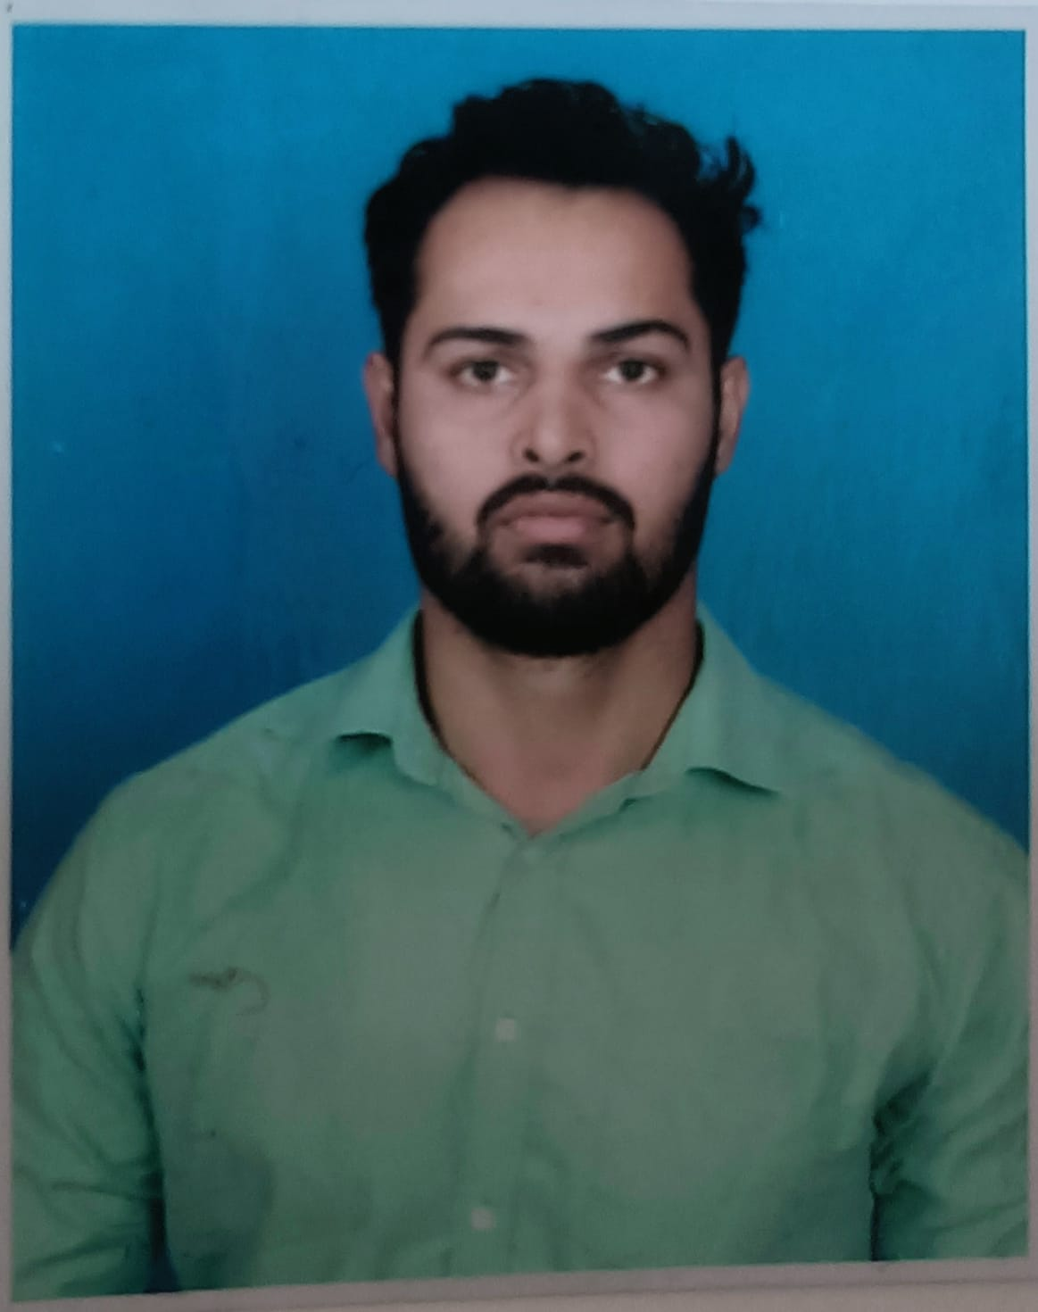
Rohit Mahalawat
Smec India (Gurugram)
Package: 6.6 lakhs
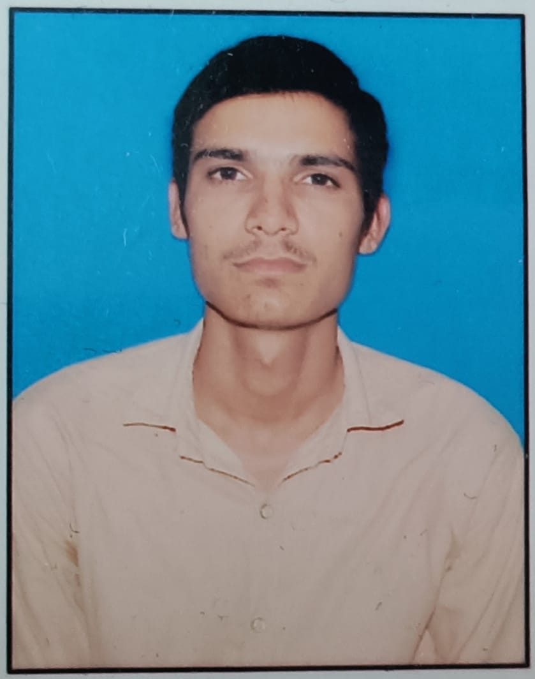
Ram Mohan
SFC Solutions (Neemrana)
Package: 4 lakhs

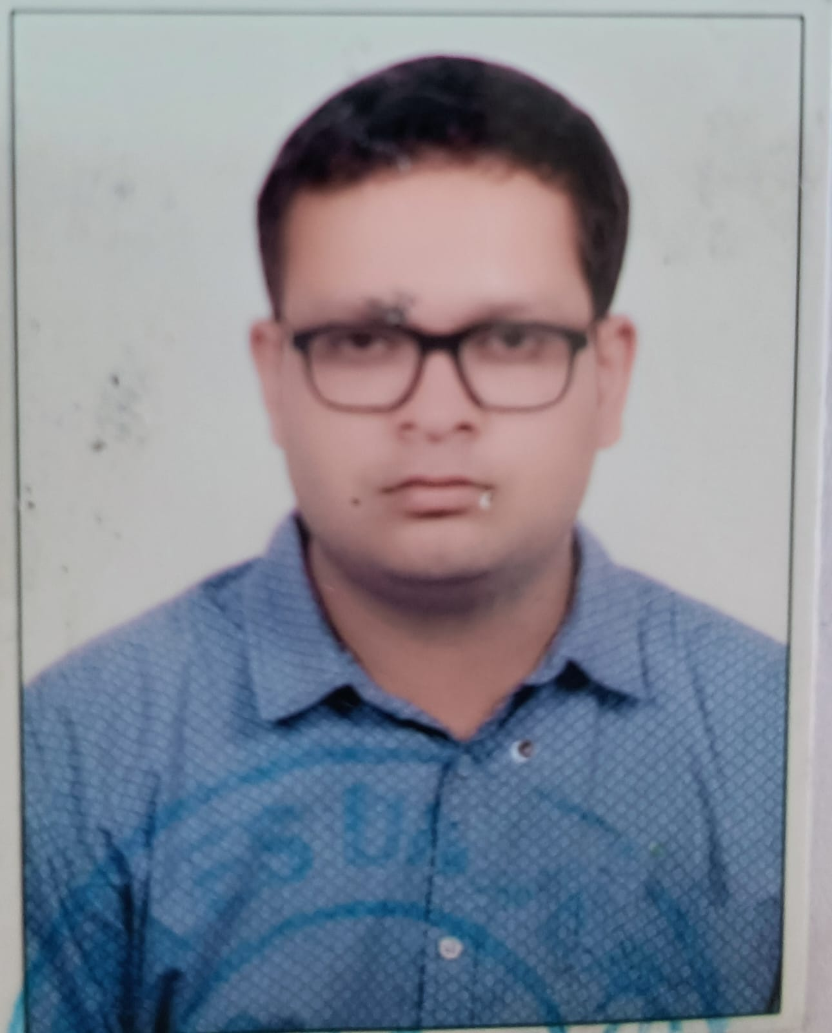
Punit Kumar Saini
Astral Pipes (Alwar)
Package: 3.6 lakhs

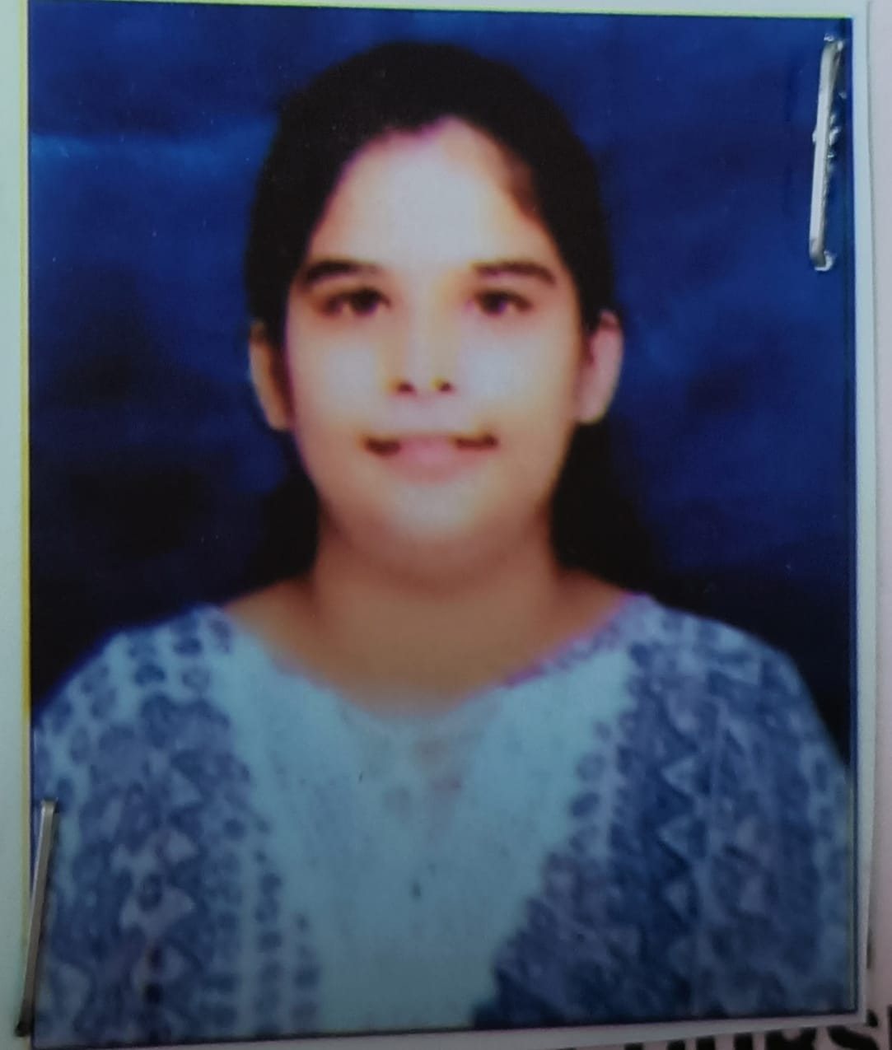
Vidhi Middha
Indo Nissin Foods (Bawal)
Package: 4.8 lakhs
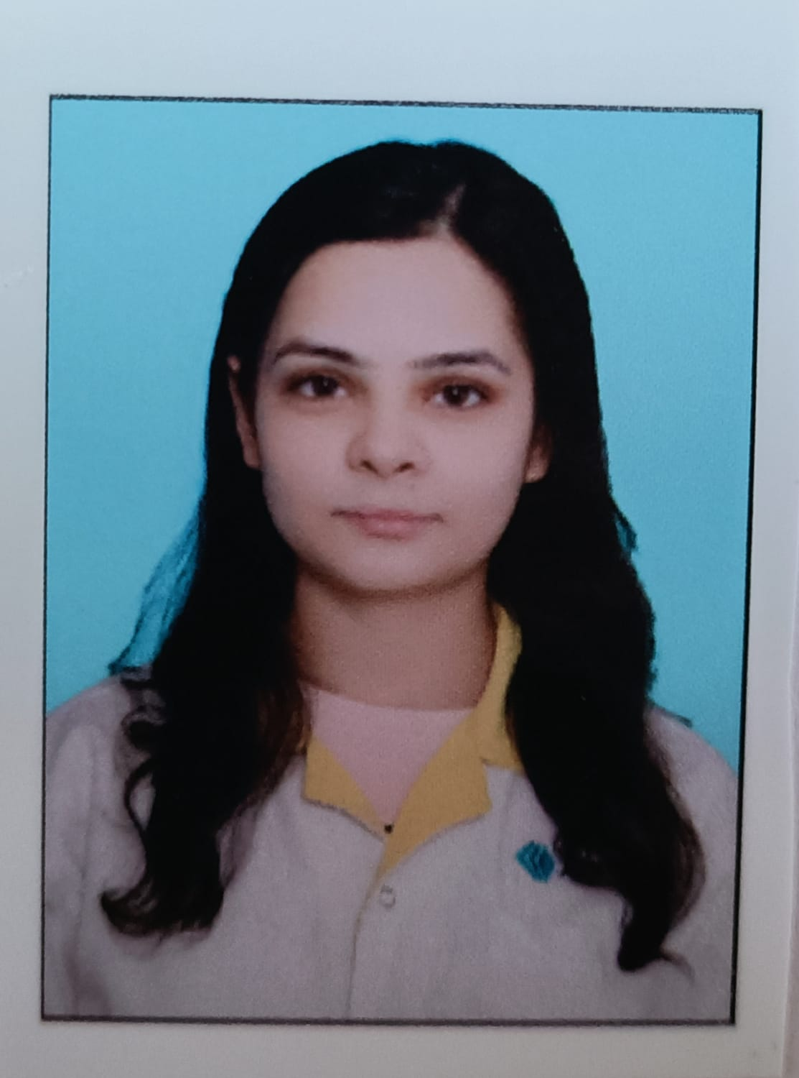
Tamanna
Alsok India (Rewari)
Package: 3.6 lakhs

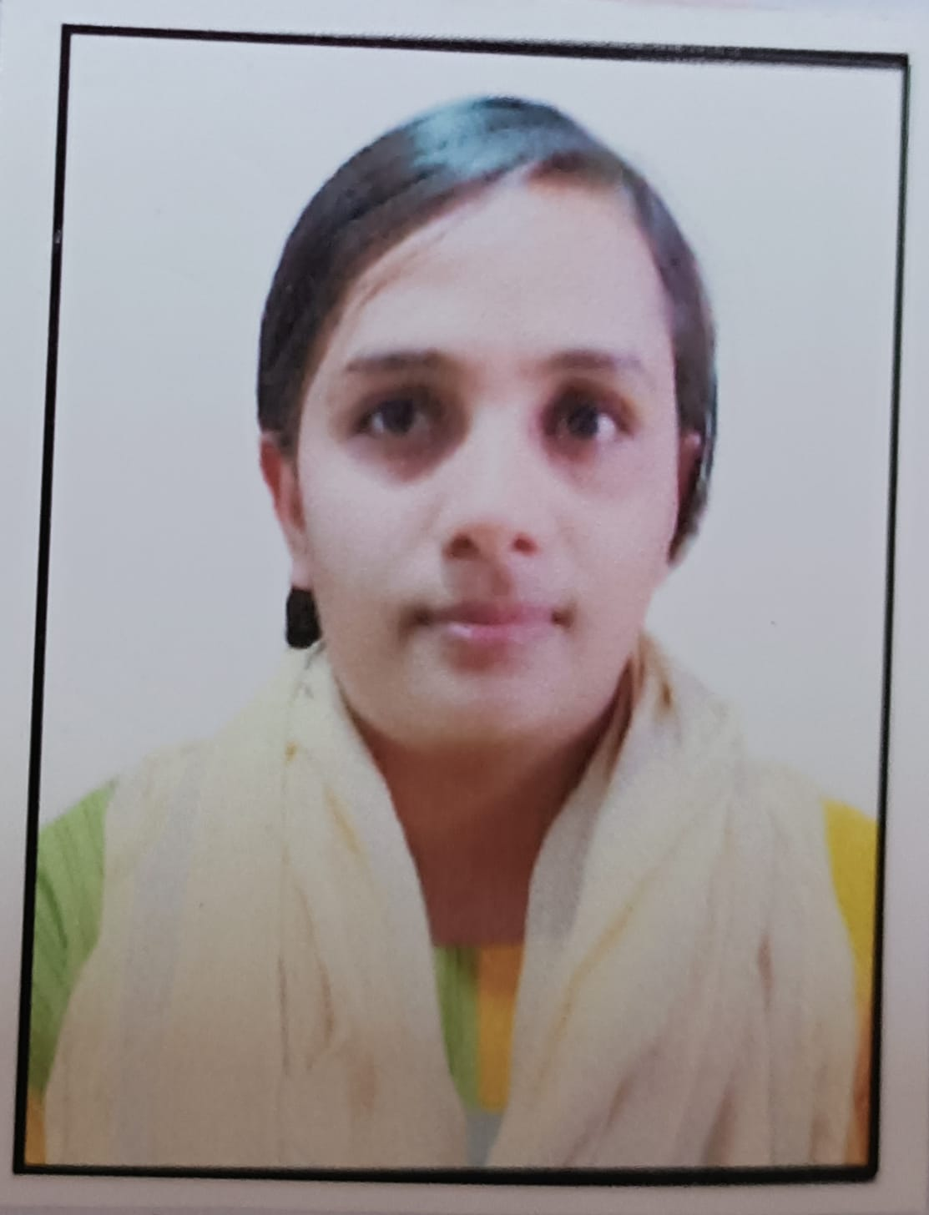
Twinkle
Daisy Motors (Bawal)
Package: 3.6 lakhs

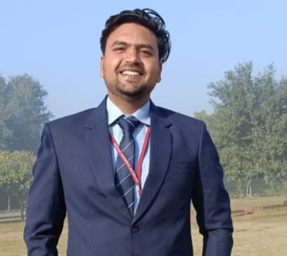
Basant
ITC (Jaipur)
Package: 4.2 Lakhs
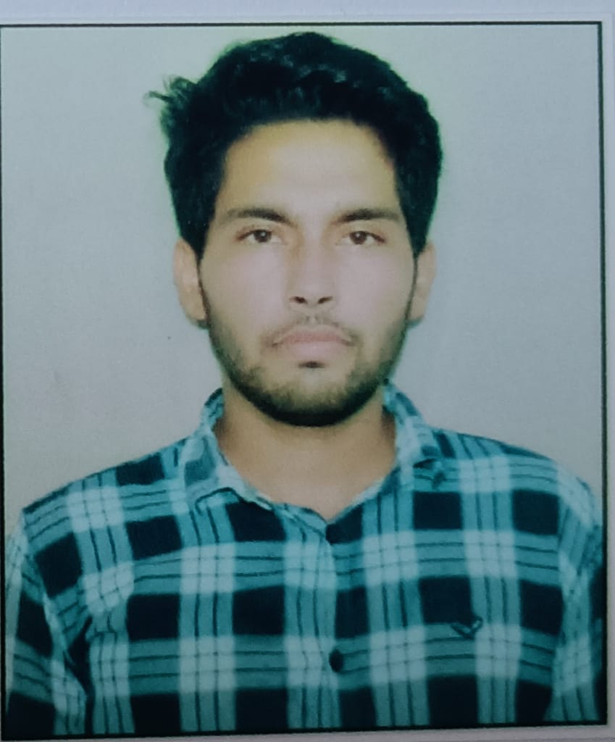
Yogesh Kumar
Daikin (Neemrana)
Package: 4 lakhs
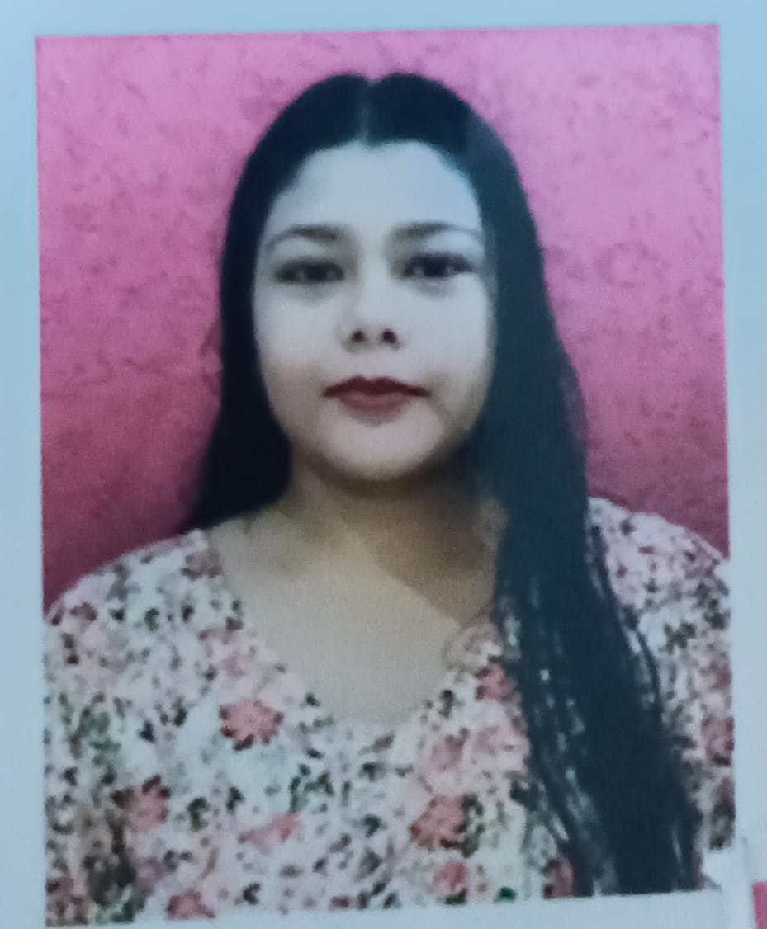
Aakansha
Genpact (Gurugram)
Package: 3.6 lakhs

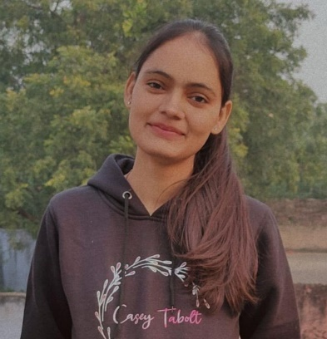
Nishu Bai
TPR Autoparts
Package: 3.6 lakhs

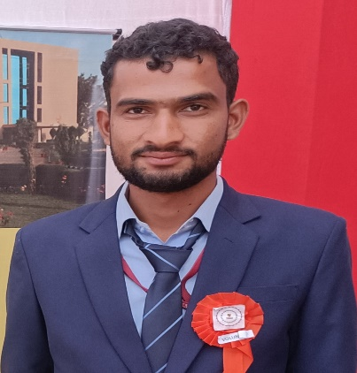
Sachin
Synaty Automotive Pvt. Ltd.
Package: 3 lakhs

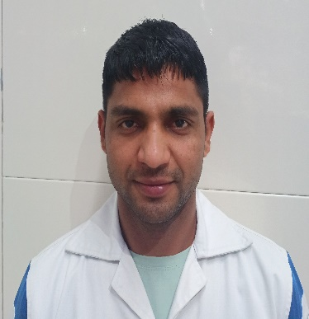
Ashwani
JTKET India Ltd.
Package: 8.6 lakhs

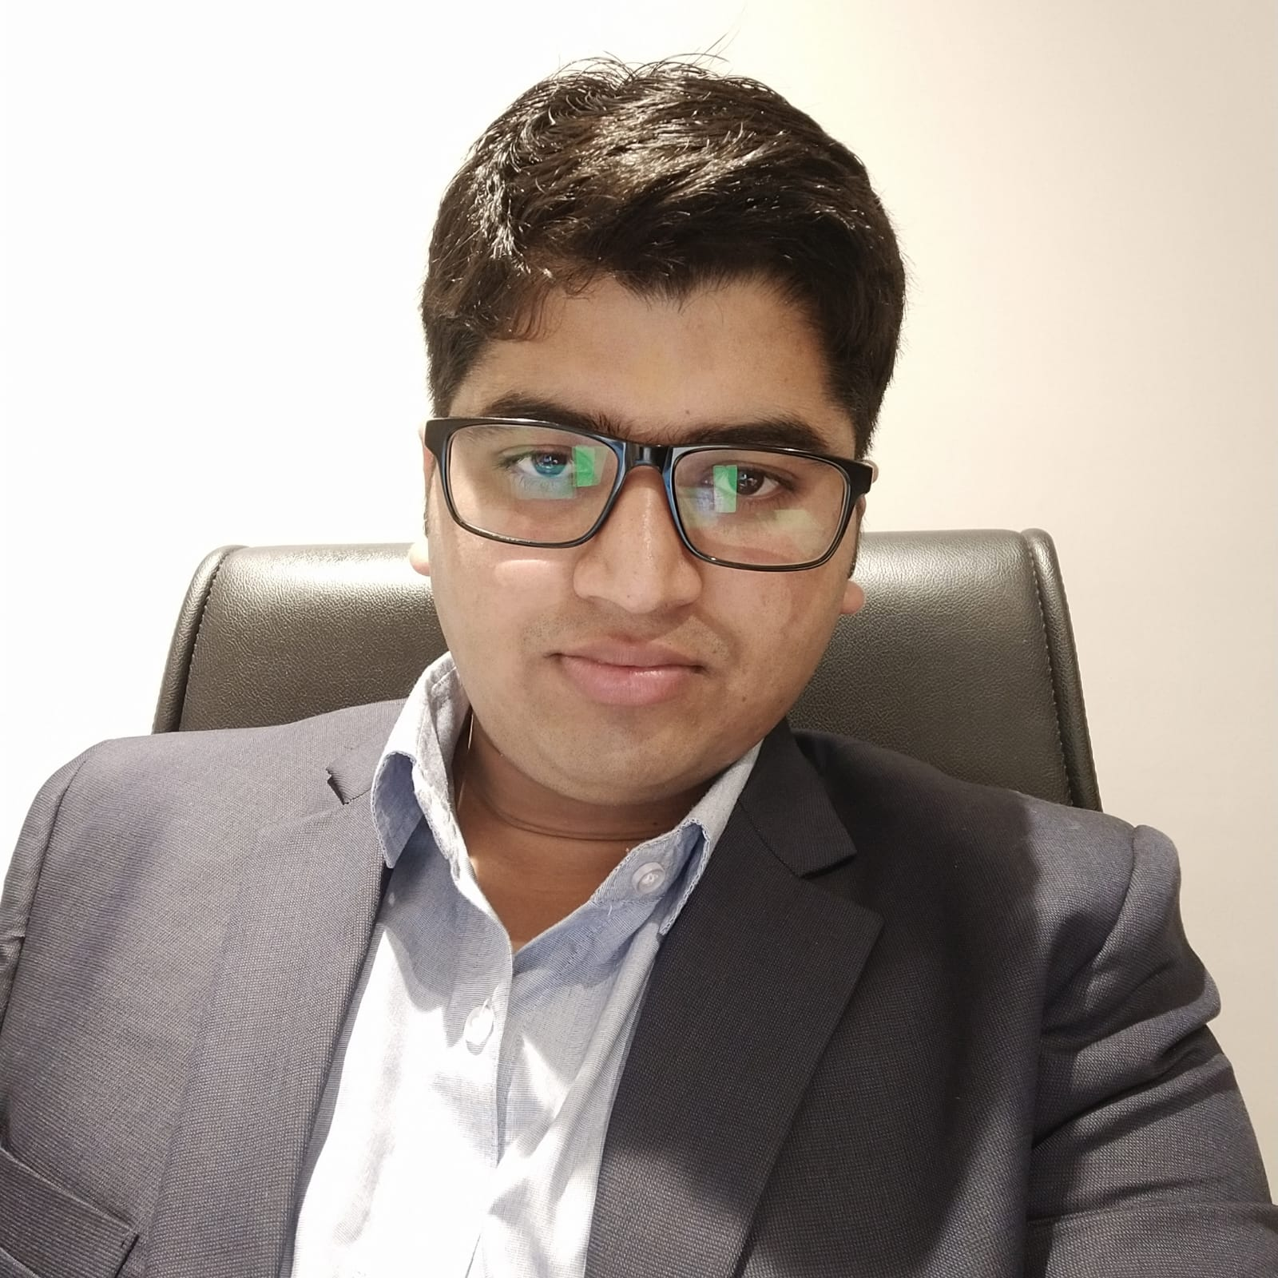
Abhinav Kumar
Hyatt Place
Package: 12 lakhs

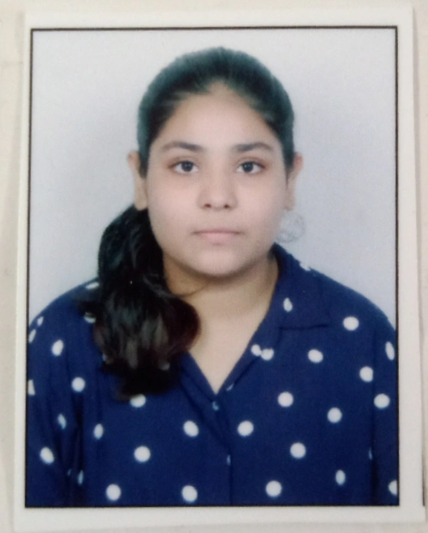
Diya Sharma
ATL Battery Technology
Package: 4.2 lakhs

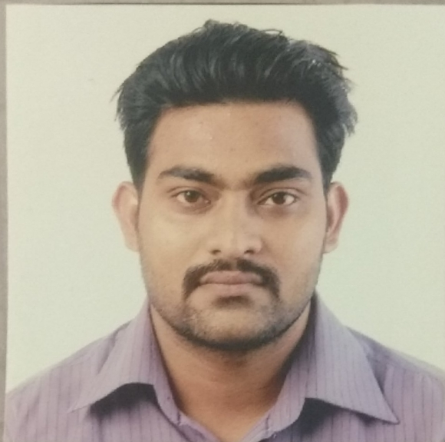
Inderjeet Singh
TPR Autoparts
Package: 16 lakhs

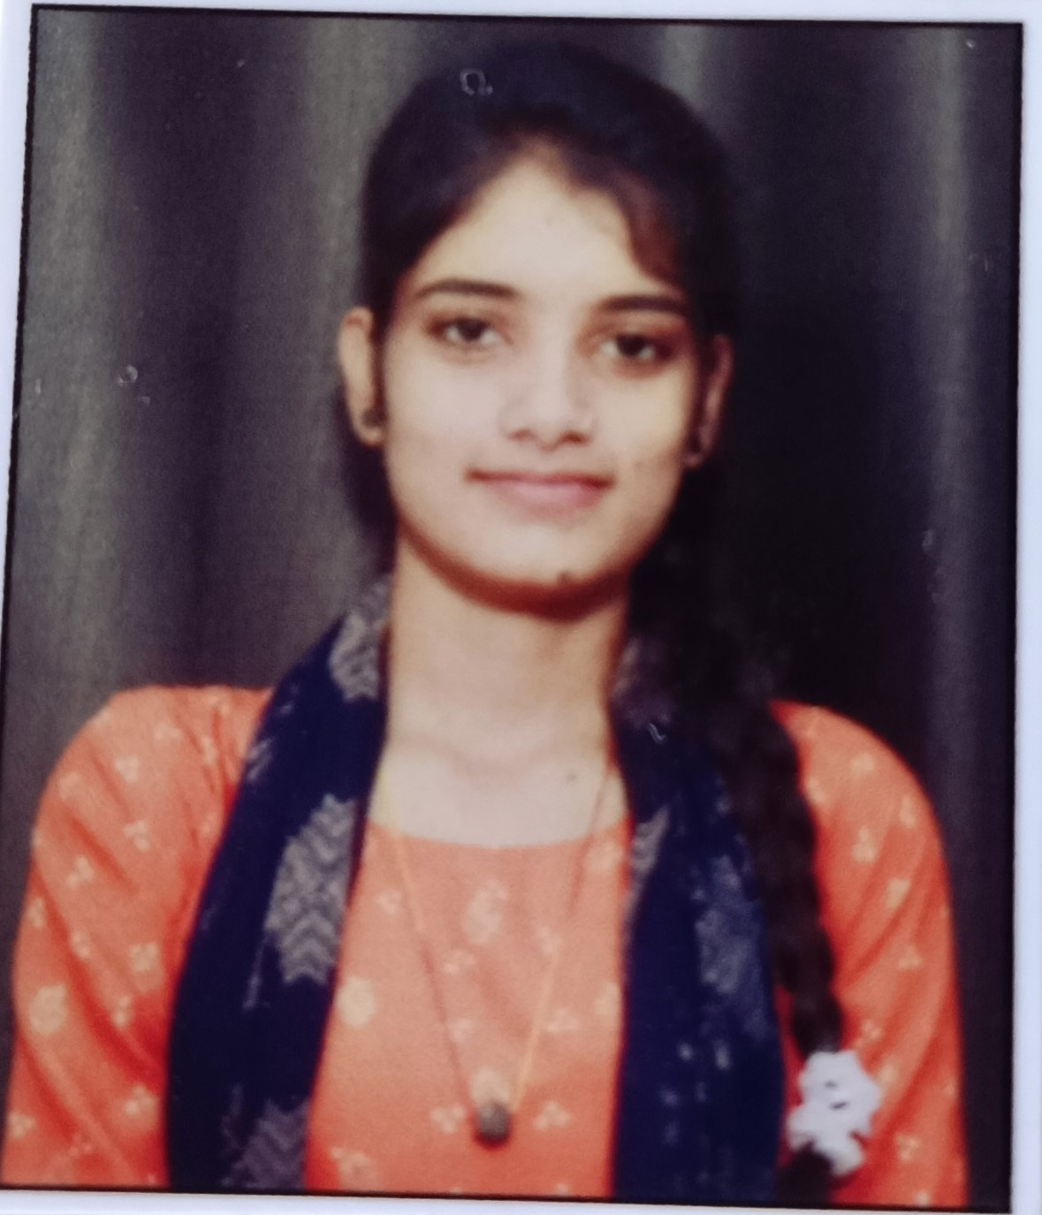
Seema
Synaty Automative Pvt. Ltd.
Package: 3 lakhs

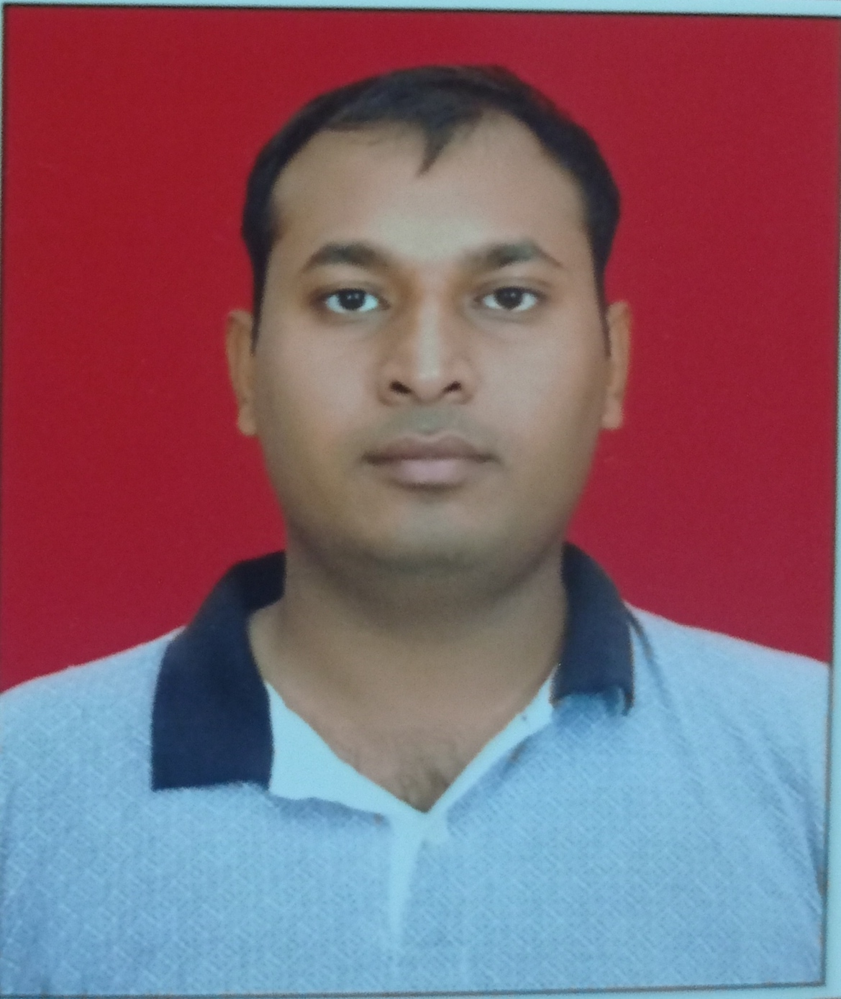
Nitesh Kumar
Lumax Industries
Package: 3 lakhs

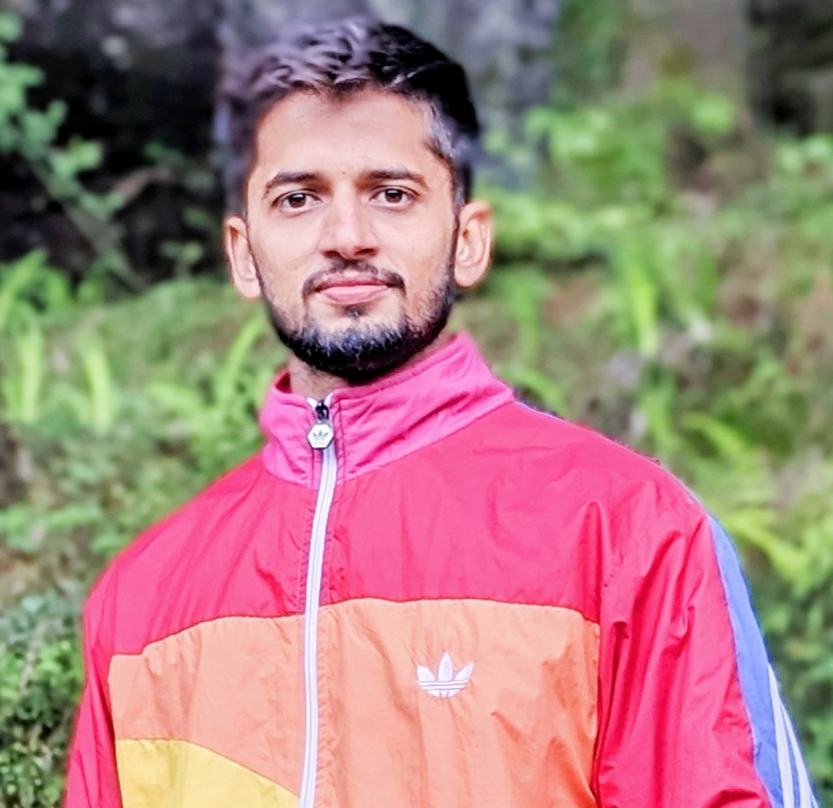
Aashish
Maruti Suzuki
Package: 3.6 lakhs

